0503-0133_US

1. Identification
Product identifier
KEIM SINTER WATER (KALK-SINTERWASSER)

Recommended use of the chemical and restrictions on use
Use of the substance/mixture
Thinner/diluent and fixing agent for lime paints in interior areas.

Details of the supplier of the safety data sheet
Company name: | KEIM Mineral Coatings of America, Inc
Address: | 10615 Texland Boulevard, #600  Charlotte, NC 28273, USA
Telephone: | 1 704-588-4811
Emergency phone number: | in US and Canada:  1 800 535 5053 (INFOTRAC)

2. Hazard(s) identification

Classification of the chemical
29 CFR Part 1910.1200 Hazard categories:
Skin corrosion/irritation: Skin Irrit. 2
Serious eye damage/eye irritation: Eye Dam. 1 Hazard Statements:
Causes skin irritation
Causes serious eye damage

Label elements

29 CFR Part 1910.1200 Signal word: Danger
Pictograms: 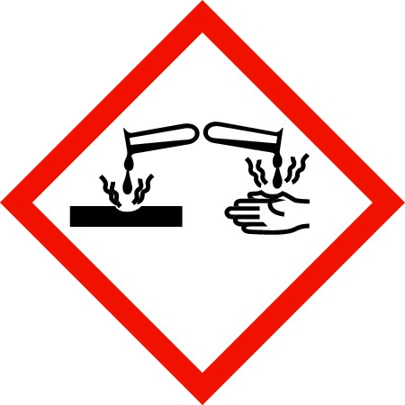

Hazard statements
Causes skin irritation
Causes serious eye damage

Precautionary statements
Keep out of reach of children.
Wear protective gloves/protective clothing/eye protection/face protection.
If in eyes: Rinse cautiously with water for several minutes. Remove contact lenses, if present and easy to do. Continue rinsing.
Get immediate medical advice/attention.
If on skin: Wash with plenty of water.
Take off contaminated clothing.
If skin irritation occurs: Get medical advice/attention.
Additional advice on labelling
The product does not require a hazard warning label.

Hazards not otherwise classified
Alkaline product. Avoid contact with skin, eyes and clothing.
Handle in accordance with good industrial hygiene and safety practice.

3. Composition/information on ingredients
0503-0133_US

Mixtures
Chemical characterization
Saturated and ready-to-use solution of slaked pit lime in water.

Hazardous components
CAS No | Components | Quantity
1305-62-0 | Calcium dihydroxide | < 2,5 %

4. First-aid measures

Description of first aid measures

General information
No special measure necessary.
Show this safety data sheet to the doctor in attendance.

After inhalation
Take affected person into fresh air.
In the event of symptoms refer for medical treatment.

After contact with skin
Wash off with soap and plenty of water.
Consult a doctor if skin irritation persists.
Do not use solvents or thinners.

After contact with eyes
Rinse immediately with plenty of water, also under the eyelids, for at least 15 minutes. Seek medical treatment by eye specialist.

After ingestion
Rinse out mouth and give plenty of water to drink.
Do not induce vomiting.
Call a physician immediately.
Most important symptoms and effects, both acute and delayed No data available.
Indication of any immediate medical attention and special treatment needed Treat symptoms.

5. Fire-fighting measures

Extinguishing media
Suitable extinguishing media
Product itself does not burn. Fire-extinguishing activities according to surrounding building materials.

Specific hazards arising from the chemical
In case of fire formation of dangerous gases possible. (Carbon monoxide (CO), silicon dioxide) In case of fire and/or explosion do not breathe fumes.
Special protective equipment and precautions for fire-fighters Use breathing apparatus with independent air supply.

Additional information
Fire residues and contaminated firefighting water must be disposed of in accordance with the local regulations.

6. Accidental release measures

Personal precautions, protective equipment and emergency procedures
Avoid contact with skin, eyes and clothing.
Ensure adequate ventilation. Keep away noninvolved persons.
Environmental precautions No special measures required. 0503-0133_US

Methods and material for containment and cleaning up
Soak up with inert absorbent material (e.g. sand, silica gel, acid binder, universal binder). Shovel into suitable container for disposal.
Clean contaminated surface thoroughly.
No dangerous substances are released.

Reference to other sections
Information for disposal look up chapter 13.

7. Handling and storage

Precautions for safe handling

Advice on safe handling
Avoid contact with skin, eyes and clothing.
Keep container tightly closed.
Avoid formation of aerosolized spray mist.
Keep a good ventilation and air-exhaust at the place of work.
Advice on protection against fire and explosion Cool containers at risk with water spray jet.

Conditions for safe storage, including any incompatibilities

Requirements for storage rooms and vessels
Keep only in unopened original container. Keep in a dry, cool and well-ventilated place. Do not use aluminium containers.
Advice on storage compatibility Do not store together with acids.
Further information on storage conditions To be kept tightly closed, in a cool and dry place.
Keep from freezing.
Protect from heat and direct solar radiation.

8. Exposure controls/personal protection

Control parameters

Exposure limits
CAS No. | Substance | ppm | mg/m³ | f/cc | Category | Origin
1305-62-0 | Calcium hydroxide Respirable fraction | - | 5 |  | TWA (8 h) | PEL
1305-62-0 | Calcium hydroxide | - | 5 |  | TWA (8 h) | REL
 |  |  | 5 |  | TWA (8 h) | ACGIH-2016
57-50-1 | Sucrose (resp) | - | 5 |  | TWA (8 h) | REL
57-50-1 | Sucrose Respirable fraction | - | 5 |  | TWA (8 h) | PEL

Exposure controls
Appropriate engineering controls
The product contains no relevant quantities of materials with critical values that require monitoring at the workplace.

Protective and hygiene measures
Do not inhale aerosolized spray mist.
Take off immediately all contaminated clothing.
Avoid contact with skin, eyes and clothing.

Eye/face protection
Eye wash bottle with pure water. Tightly fitting goggles. 0503-0133_US

Hand protection
Chemical-resistant gloves (EN 374) / NIOSH/MSHA approved
Chemical protective gloves made of nitrile, nitrile/cotton, butyl or neoprene, with a minimum thickness of 0.7 mm, permeation time of approx. 480 minutes. Select the appropriate glove material adhering to the breakthrough time, permeation rate and the degradation.
Skin protection Long sleeved clothing.

Respiratory protection
Not required; except in case of aerosolized spray mist.
Mask with filter Type P (EN 141), NIOSH/MSHA approved

9. Physical and chemical properties

Information on basic physical and chemical properties
Physical state: Color: | Liquid  White
Odor: | Odorless
pH-Value (at 20 °C):  Changes in the physical state | Alkaline | *
Melting point/freezing point: | n.d.
Initial boiling point and boiling range: | ~ 100 °C
Flash point: | n.a.
Explosive properties | The product is not explosive.
Oxidizing properties | The product is not self-igniting.
Vapor pressure: (at 20 °C) | 23 hPa
Density (at 20 °C): | 1,0 - 1,1 g/cm³ | *
Water solubility: | Miscible
Viscosity / dynamic: | Not determined | *

Other information
No data available.
* The values are for freshly produced material and may change with the time.

10. Stability and reactivity
Reactivity
Stable under normal conditions.

Chemical stability
Stability: Stable
Stable under normal conditions.

Possibility of hazardous reactions
Hazardous reactions: Will not occur
None under normal processing.

Conditions to avoid
Keep from freezing.
Protect from heat and direct solar radiation.

Incompatible materials
Acids.
Aluminium

Hazardous decomposition products
No decomposition if stored and applied as directed.
0503-0133_US

11. Toxicological information

Information on toxicological effects
Route(s) of Entry
Skin and eye contact, inhalation and ingestion.
Acute toxicity
Based on available data, the classification criteria are not met.

Irritation and corrosivity
Causes skin irritation
Causes serious eye damage
Sensitizing effects
Based on available data, the classification criteria are not met.
Specific target organ toxicity (STOT) - single exposure
Based on available data, the classification criteria are not met.
Severe effects after repeated or prolonged exposure
Based on available data, the classification criteria are not met.

Carcinogenic/mutagenic/toxic effects for reproduction
Based on available data, the classification criteria are not met.
Carcinogenicity (NTP): | Not listed
Carcinogenicity (IARC): | Not listed
Carcinogenicity (OSHA): | Not listed

Aspiration hazard
Based on available data, the classification criteria are not met.

12. Ecological information

Ecotoxicity
No toxicological data available. Persistence and degradability No data available.
Bioaccumulative potential No data available.

Mobility in soil
No data available.
Other adverse effects Slightly water hazardous.

Further information
Do not flush into surface water or sanitary sewer system.

13. Disposal considerations

Waste treatment methods
Advice on disposal
Disposal in accordance with local regulations.

Contaminated packaging
Disposal in accordance with local regulations. Cleaning agent: Water

14. Transport information

US DOT 49 CFR 172.101
Proper shipping name: Not regulated.
0503-0133_US

Marine transport (IMDG)
UN proper shipping name:  Air transport (ICAO-TI/IATA-DGR) | Not regulated.
UN number: | UN 3266
UN proper shipping name: | CORROSIVE LIQUID, BASIC, INORGANIC, N.O.S. (CALCIUM  DIHYDROXIDE)
Transport hazard class(es): | 8
Packing group: | III
Hazard label: | 8
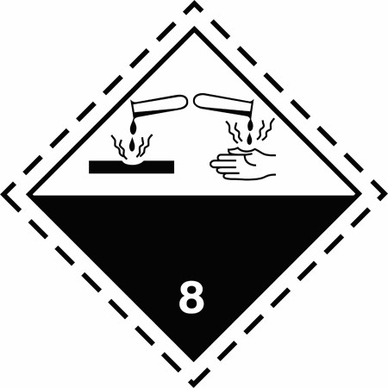
Limited quantity Passenger: | 1 L
Passenger LQ: | Y841
Excepted quantity: | E1
IATA-packing instructions - Passenger: |  | 852
IATA-max. quantity - Passenger: |  | 5 L
IATA-packing instructions - Cargo: |  | 856
IATA-max. quantity - Cargo: |  | 60 L

15. Regulatory information

U.S. Regulations

National Inventory TSCA
All of the components are on the TSCA Inventory.
National regulatory information SARA Section 311/312 Hazards:
Calcium dihydroxide (1305-62-0): Immediate (acute) health hazard

State Regulations

Safe Drinking Water and Toxic Enforcement Act of 1986 (Proposition 65, State of California)
This product contains no chemicals known to the State of California to cause cancer, birth defects or other reproductive harm.

16. Other information

Hazardous Materials Information Label (HMIS)
Health: 1  Flammability: 0  Physical Hazard: 0  NFPA Hazard Ratings Health: Flammability: Reactivity: Unique Hazard: 1 0 0  Revision date: Revision No: 14.02.2017 12,0 | 0  1  0
0503-0133_US

Abbreviations and acronyms
IMDG = International Maritime Code for Dangerous Goods
IATA/ICAO = International Air Transport Association / International Civil Aviation Organization
MARPOL = International Convention for the Prevention of Pollution from Ships
DOT = Department of Transportation
TDG = Transport of Dangerous Goods
GHS = Globally Harmonized System of Classification and Labelling of Chemicals
CAS = Chemical Abstract Service
ISO = International Organization for Standardization
LD = Lethal dose
LC = Lethal concentration
EC = Effect concentration
IC = Median immobilisation concentration or median inhibitory concentration

Other data
The information in this document is based on the present state of knowledge and is applicable to the product with regard to appropriate safety precautions.
The information describes exclusively the safety requirements for the product (s) and is based on the present level of our knowledge.
The delivery specifications are contained in the corresponding product sheet.
This data does not constitute a guarantee for the characteristics of the product(s) as defined by the legal warranty regulations.
(n.a. = not applicable; n.d. = not determined)

